Extra Topic (Stored Procedure)

Query1: This query will merge the dataset of farmer's current and past season's crop state wise.

CREATE PROCEDURE `statewise_farmer_detail`(IN current_cropID VARCHAR(10),

IN previous_cropID VARCHAR(10),IN state_ VARCHAR(25))

BEGIN

SELECT farmer.First_name, current_season_crop.crop_ID as current_crop_ID,

previous_season_crop.crop_ID as previous_crop_ID,current_season_crop.Expected_production, previous_season_crop.production as produced_crop

FROM ((farmer INNER JOIN current_season_crop ON farmer.F_ID =

current_season_crop.F_ID) INNER JOIN previous_season_crop ON farmer.F_ID =

previous_season_crop.F_ID) WHERE current_season_crop.crop_ID= current_cropID

AND previous_season_crop.crop_ID= previous_cropID AND state=state_;

END

CALL statewise_farmer_detail ('gujarat')

Output:

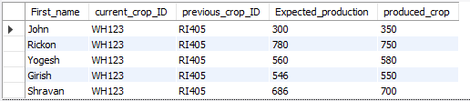

Query2: This query will give the crop buyer detail with their experience status based on their ratings and total deals done.

CREATE PROCEDURE `Experienced_crop_buyer`(IN state_ VARCHAR(25), IN District_ VARCHAR(25))

BEGIN

SELECT CB_ID, First_Name,contact_No, district,Ratings,Total_deals_done,

CASE WHEN Total_deals_done>=500 THEN 'experienced'

WHEN Total_deals_done>=300 AND Total_deals_done<500 THEN 'quite experienced'

ELSE 'not_experienced'

END AS experience_status FROM crop_buyer

WHERE state='gujarat' AND crop_buyer.CB_ID= ANY (SELECT crop_buyer.CB_ID FROM

crop_buyer WHERE Total_deals_done>200) AND state=state_ AND district=district_

ORDER BY(Total_deals_done);

END

Output:

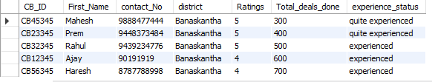

Query3: This query will give average price and average stalk available per fertilizer dealer per state.

CREATE PROCEDURE `fertilizer_detail`(IN state_ VARCHAR(25),

IN Fertilizer_ID_ VARCHAR(10))

BEGIN

SELECT AVG(fertilizer_availability.Price) As Avg_price,

AVG(Available_stock) As Avg_available_stock

FROM fertilizer_availability, fertilizer_dealer, fertilizer

WHERE fertilizer.Fertilizer_ID= fertilizer_availability.Fertilizer_ID=Fertilizer_ID_

AND Fertilizer_dealer.state=state_;

END

CALL fertilizer_detail('gujarat','FE1232')

Output:

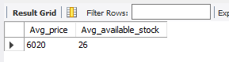

Query4: This query will give list of top fertilizer dealer in particular state on the basis of quantity of fertilizer they have sold.

CREATE PROCEDURE `top_fertilizer_dealers`(IN State_ VARCHAR(25))

BEGIN

SELECT fertilizer_dealer.Fd_ID, Contact_No, First_name, District

FROM fertilizer_dealer,fertilizer_deal

WHERE fertilizer_deal.Fertilizer_ID='FE1232' AND

EXISTS (SELECT Quantity_of_Fertilizer FROM fertilizer_deal WHERE

Quantity_of_Fertilizer>190 ) AND fertilizer_dealer.state=state_

AND fertilizer_dealer.Fd_ID= fertilizer_deal.Fd_ID

ORDER BY (Amount_paid) ASC;

END

CALL top_fertilizer_dealers('gujarat')

